Houston Texans Advertising Plan
Welcome Home
Faith Eissler
November 19, 2013

Table of Contents

- Executive Summary
- Problem Statement
- Background Information
- Target Audiences
- Competition and Research
- Strategic Recommendations

- Situation Analysis
- Historical Background
- Industry Analysis
- Market Analysis
- Competitor Analysis
- S.W.O.T. Analysis

- Objectives
- List of Objectives
- Analysis

- Budget
- Method
- Amount
- Justification

- Strategies and Execution
- Membership Cards
- Academy Sports + Outdoors
- Social Media Strategies

- Testing and Evaluation
- Method

- Executive Summary

Problem Statement:
The Houston Texans organization wishes to increase their fan base and create lasting impressions with their fans. The purpose of this campaign is to increase returning ticket buyers by 25% for the upcoming season. The Texans organization wants all of their fans to be repeat customers, rather than just attending one game here and there. We want to upgrade our single-game ticket buyers to mini-plan holders, or season ticket holders.
Background:
The Houston Texans are an NFL team that plays at Reliant Stadium in Houston, Texas. The franchise has been around since 2002, and the Texans play in the AFC South Division. The Texans were AFC South Champions in 2011 and 2012, and they were in the playoffs in 2012, as they defeated the Cincinnati Bengals in the Wild Card Game.
Target Audience:
The target audience for the Houston Texans organization’s “Welcome Home” campaign is recent college graduates. Houston has several job opportunities for young professionals, and many people relocate to Houston after finishing college. There are several transplants in Houston, and the Texans want to provide a new place for these folks to call home. We want them to raise their families to be Texans fans, and we want going to Texans games to be a tradition for them.
Competition and Research:
Competition for the Houston Texans organization is the Dallas Cowboys, the New Orleans Saints, and Texas A&M University. All of these football clubs are relatively close in location, and all of these programs have successful team performances, as well as fan bases and advertisement. The table below represents research for the Texans organization and its competitors in terms of Facebook likes and Twitter followers. The Texans are a new organization, and they are in very close competition with the New Orleans Saints organization.
Team | Facebook Likes | Twitter Followers
Houston Texans | 1,086,634 | 335,173
Dallas Cowboys | 5,706,938 | 556,116
New Orleans Saints | 3,108,986 | 397,278
Texas A&M Aggies | 102,690 | 84,062

Strategic Recommendations:
I recommend that the Houston Texans launch new social media campaigns for the “Welcome Home” campaign. Launching a “Welcome Home” campaign through social media will put the Texans in closer competition with the New Orleans Saints on social media followership. In addition, I suggest implementing a membership rewards program this season at Reliant Stadium. In order to receive the card, called “My Home Rewards,” they must fill out their name, contact information, and interests about the Texans organization. We want Reliant Stadium to feel like a second home for our fans. We will track fan activity at Reliant Stadium, and each swipe will award the member points. Accumulating these points can lead to rewards, such as discounted tickets, merchandise, or meet and greets with the Texans players and staff members.
- Situation Analysis
Historical Background:

According to a 2011 fan guide, the mission statement of the Houston Texans “is to create and maintain the most respected and most valuable professional sports franchise in the world.”
The Texans were established in 2002, and they were formerly known as the Houston Oilers. The Texans play in the AFC South Division, and they were Division champions in both 2011 and 2012.
The ultimate goal of the Houston Texans organization is to create brand loyalty and to sell corporate sponsorships at Reliant Stadium. In order to create brand loyalty, the organization must create a catchy advertising campaign in order to reach out to their target audiences, in this case, recent college graduates.
Industry Analysis:

According to an article on YoExpert.com, the NFL is extremely popular, and the NFL generates over $9 billion in revenue each season. The NFL also has popular social media outlets, and according to the website, the NFL is popular because it has a network that broadcasts football-related programming 24 hours a day.
According to an article in the Huffington Post, the sports industry is expected to continue to grow. Revenue generated by ticket sales and sponsorships is expected to increase by 3.7 percent until 2015 (Huffington Post).
Market Analysis:
The current target market of the Houston Texans brand is recent college graduates. Houston has a booming economy, and many people relocate to Houston to find jobs. In fact, several people who live in Houston are transplants, which means they were born in another state and later relocated to Houston. We are reaching out to those aged 21-26 with our advertising campaign. Since most recent college graduates are entering the workforce, they will have more income than in years past, and attending Houston Texans games will still allow them to watch football every week like they did when they were in college.
People have become more loyal to the Texans brand. During the beginning seasons of the Texans franchise, team performance was not that great. In 2011 and 2012, the Texans were AFC South Division Champions, and the Texans even went to the playoffs in 2012. Since team performance has increased, fans have grown more loyal to the Texans brand. Recent college graduates like the Texans brand because it is new and fresh, and because the Texans tailgating experience is like none other. There are several perceived benefits from the Texans brand, and when people wear gear or watch the games, they feel like they are representing their new hometown, as well as their new home state. A popular tagline for the Texans brand is, “We Are Texans.” This unites people across the entire state of Texas, and not just in the Houston area. Since recent college graduates are most likely working at entry-level jobs, price of tickets will affect the purchase decision. In addition, the same goes for merchandise or sponsorships. If a recent college graduate is looking at a sponsorship spot for their new company, they will think how the advertisement will make their company look in Reliant Stadium. There are geographic differences in the target market for the Texans brand, as several people who live in Houston are originally from another state. Houston is the new home for several people from all across the country.
Competitor Analysis:

There are 3 major competitors for the Houston Texans brand.

- Dallas Cowboys
- New Orleans Saints
- Texas A&M University

The Dallas Cowboys are the most popular team in the National Football League. Located just 4 hours north of Houston, the Cowboys have the largest replay screen in professional sports. The Cowboys also lead the NFL in merchandise sales, and they are currently leading their division. Houston is in next to last place in their division. According to an online ESPN article, the Cowboys lead the NFL in attendance, with nearly 350,000 fans in attendance at home games so far this season. The Cowboys are said to be America’s team, and this has helped them market in the past.
The New Orleans Saints are also a source of competition for the Texans. New Orleans is 5 hours away from Houston, and several people in Houston travel to New Orleans on weekends. The Saints have a new stadium, and team performance is up for the Saints. The Saints hosted the Super Bowl last year, so that might make people more interested in going to Saints games. In addition, Drew Brees is one of the most successful quarterbacks in the NFL, as he has broken records in previous seasons. The Saints also have a recent Super Bowl championship, as they won it all in 2010.
Texas A&M University football also serves as competition to the Texans. Texas A&M football fans are very loyal, and the university has a strong fan base. Texas A&M is also home to the 2012 Heisman trophy winner, Johnny Manziel. In addition, Texas A&M recently joined the SEC, the most popular and successful conference in all of college football. The SEC also gets the most coverage on ESPN. Last year, Texas A&M promoted their move to the SEC, and I think this was successful for their team. In addition, Texas A&M handed the University of Alabama their only loss last season. Texas A&M alumni are extremely loyal, as many of them wear their class rings and merchandise years after they have graduated.
S.W.O.T. Analysis

Strengths:
- Waiting list for tickets
- Recent success
- Fresh new talent
- Only NFL team in Houston area

Weaknesses:
- Team performance this season
- Arian Foster admitting to receiving money while playing at Tennessee (NCAA violation)
- Injuries
- Fans are questioning head coach Gary Kubiak’s decisions

Opportunities:
- Transplants and people who relocate to Houston bring new opportunities for increasing fan base
- Texans football can be the common ground people share when they move to Houston
- Houston is only second to New York City in the number of Fortune 500 companies headquartered
- Recent college graduates are new employees to Houston businesses, and the recent graduates can bring sponsorship and corporate partnerships to their business after attending Texans games

Threats:
- NFL lockout
- Competitors: Cowboys, Aggies, Saints
- Declining economy

- Objectives

- We will increase Houston Texans season ticket sales among past partial plan buyers by 15% in the months of November through February.

- We will increase raffle ticket sales among fans who attend games by 15% in the months of December and January.

- I will increase the number of recent college graduates who are aware of the Houston Texans season ticket holder benefits by 15% in the next 3 months.

- I will increase customer loyalty benefits for “My Home Rewards” members by 10% in the 2014 season.

- I will host 3 additional customer appreciation nights for season ticket holders at Reliant Stadium in January 2014 as compared to January 2013.

- I will build brand image for the Houston Texans by creating 2 social media campaigns in 3 months.

- I will increase positive attitudes toward the Texans with recent college graduates by 10% in 6 months.

Analysis
Our most important objective we want to accomplish this season is changing single-game ticket purchasers into partial season ticket plan holders or full season ticket holders. We also want to increase raffle ticket sales to benefit the Texans Foundation, as well as the Houston community. We want recent college graduates to have the Texans brand at the top of their minds, and we want them to raise their families to be Texans fans. This is the basis of the Houston Texans “Welcome Home” campaign.
- Budget
Method
The method we will be using for the budget for the “Welcome Home” campaign for the Houston Texans is the percentage-of-sales approach. According to an article on ESPN, the average attendance for Texans home games is 71,589. According to the Texans website, the average ticket price at Reliant Stadium is $86.39. The Texans are hosting 10 home games in 2013.
Amount
The Houston Texans will use 4% of the revenue generated from ticket sales for advertising. According to the textbook, it is common for an agency to use 2-12% of sales for advertising. The Texans will use 4% of the projected sales for the 2013 season toward their “Welcome Home” advertising campaign. Since the average home attendance is 71,589 per game, and there are 10 home games in 2013, the total attendance is around 715,890. The average ticket price is $86.39, so the total projected revenue for 2013 is $61,845,737.10. We decided to use 4% of the ticket sales revenue towards advertising, which would be $2,473,829.48.
Justification
According to the textbook, organizations use anywhere from 2-12% of their sales revenue on advertising. The Texans organization decided to use 4% of ticket sales revenue, because according to the Texans website, the average price per ticket has increased since the 2012 season. Therefore, the projected sales for 2013 will be higher than that of the 2012 season. Since the organization will have a little bit of extra revenue in the 2013 season, 4% of sales can be used for advertising rather than 2%.
- Strategies and Execution

Membership Cards
The first strategy exercised by the Houston Texans organization will be the integration of membership cards at Reliant Stadium. These cards will be called, “My Home Rewards.” This will emphasize the importance of the “Welcome Home” campaign. We want our fans to feel at home when they are at Reliant Stadium, so we will reward them for their purchases in and around the stadium. Fans will earn reward points every time they purchase Texans tickets, tour tickets for Reliant Stadium, merchandise at the Texans team store, raffle tickets for the Texans Foundation, tailgate passes, or concessions at Reliant Stadium. The more points our fans earn, the more prizes they are eligible for. Recent college graduates would most likely buy tailgate passes and concessions, so this would be a great way to reward our target audience. Rewards points can be redeemed for discounted Texans tickets, free tour tickets, or player and coach meet and greets. This would give our fans incentives to sign up for our rewards program, while, in turn, giving the organization valuable marketing and advertising information.
Academy Sports + Outdoors
The Texans will partner with Academy Sports + Outdoors as well for integrated brand promotion. Academy Sports + Outdoors sells Texans merchandise, and Texans players also make appearances at Academy locations. It would be wise to partner with Academy, because whenever customers purchase Texans merchandise at Academy stores, they can be informed of the “My Home Rewards” card. This might encourage shoppers at Academy to attend more Texans games, and it might encourage faithful Texans fans to shop at Academy more often. “My Home Rewards” members can swipe their card at Houston area Academy locations and receive reward points.
Social Media Strategies
According to a presentation about college students, people aged 18-24 “check social media 21+ times per day.” Recent college graduates can fall into this age range as well, which is who is being targeted by the Texans organization’s “Welcome Home” campaign. I suggest using a social media campaign for this advertising campaign. The age range is already active on social media, and the Texans have several followers and likes already. In addition, young people like to let others know what they are doing, so they can spread the word about the “Welcome Home” campaign through social media. Social media users will be rewarded as well. We will promote Texans rewards on social media, as fans who are active on social media will receive rewards. We can also obtain valuable information in this way, as people put a lot of voluntary information about their likes, dislikes, and preferences on their social media sites. We will load the comments and social media activity into our CRM system, and this will help us know our customers better. In addition, “Welcome Home” will be launched through social media. On the Twitter account for the Texans, #WelcomeHome will be trending. This will encourage fans and our target audience to share their favorite memories at Reliant Stadium, and that might encourage others to get involved as well. Not only are we reaching our own fans through this method, but we could possibly reach friends of fans on Facebook that did not already like the page or follow the account.
Below are some design layouts for the Facebook and Twitter campaigns. Each tweet or post encourages followers to share their love of Houston and the Texans with others.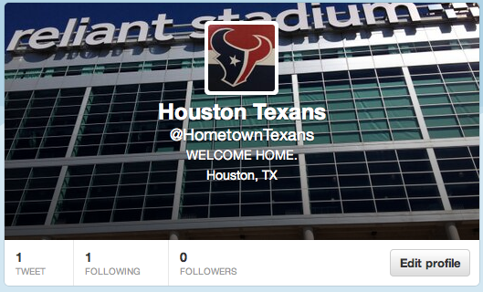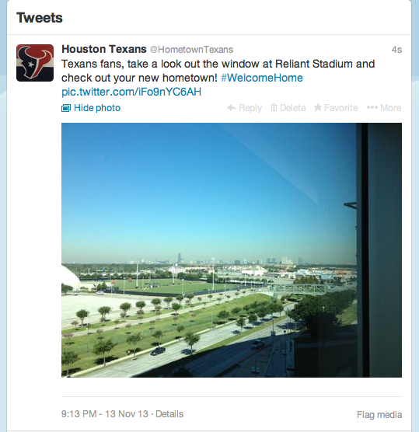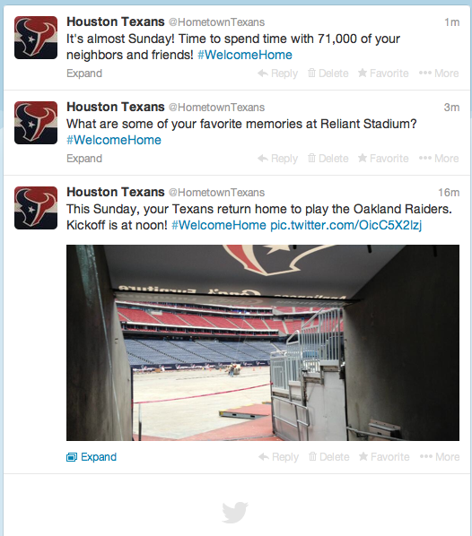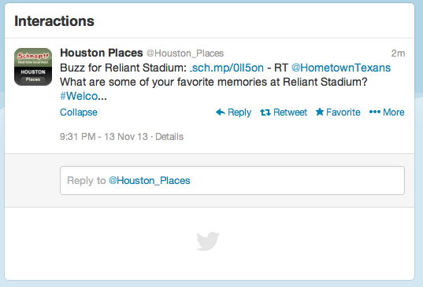The Twitter account has already seen interactio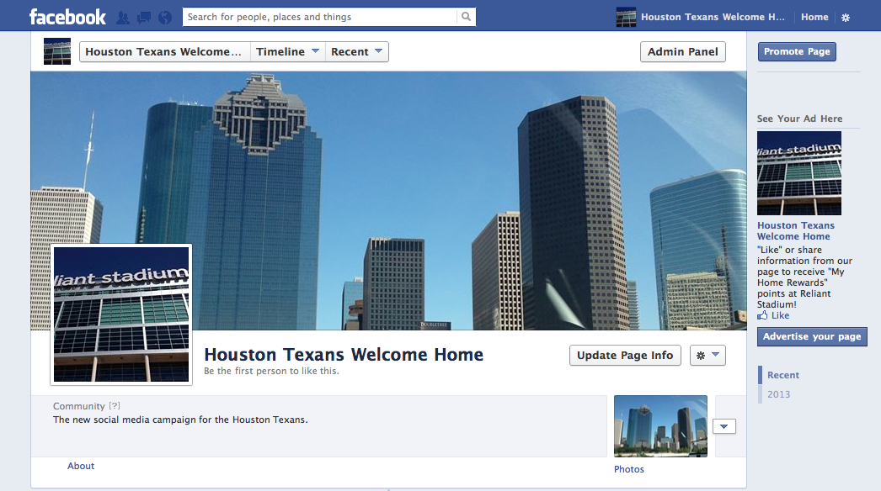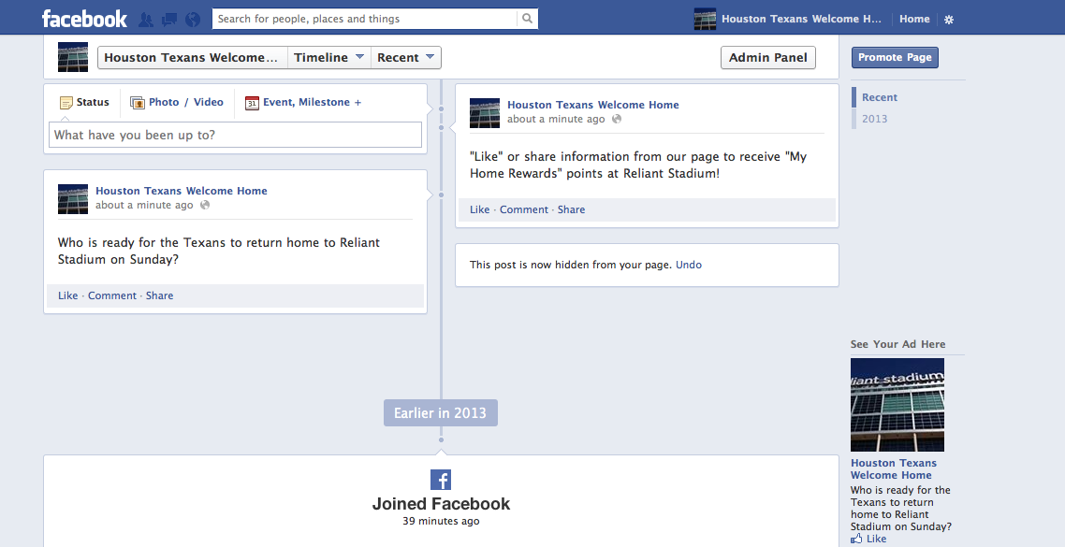
- Testing and Evaluation
We will gather our results by distributing surveys to recent college graduates and other fans in attendance at Texans games. These surveys will differ from traditional surveys, as our participants will receive incentives for completing the survey. A membership table will be set up in Reliant Stadium during every Texans home game. Fans in attendance can sign up to receive our membership card, which will be titled, “My Home Rewards.” By signing up for this membership card, we will receive valuable information about their fans, including their contact information, address, and e-mail addresses. Each time a fan purchases something at the concession stand, team store, or purchases a raffle ticket for the Texans Foundation, we will award them points. Fans can scan their card at the gate, and our sales staff can use these to generate new leads. We will also reward our followers for participating on social media, as we will track their comments, likes, and shares. We will then load these comments into our CRM system so we have up-to-date information on our customers. By keeping track of this, we can see who is involved with the Texans, and we can also reward them for spreading the word. Social media users are also eligible for membership points toward discounted tickets, discounted merchandise, meet and greets with players, coaches, and front office staff, and so on. By creating a survey with incentives such as membership points or vouchers for discounted and free Texans tickets, we will increase our number of participants.

